University of GUELPH
Organic Food Prices
Brand Preferences
Stephanie Coutinho, 0596495
4/12/2011

Executive Summary
The market for organic foods is a booming business in Canada and has shifted from niche to mainstream, with sales reportedly rising by 20% a year for the past decade (Fleece, 2009). With the growing interest of organic foods also come certain perceptions, and misconceptions about the organic food market. This is relevant considering that perception plays an important role in consumers purchase behaviour and willingness to pay for products. Canadians perceive organic foods as safer and healthier (64%) in comparison to conventional foods. Moreover, 68% of Canadian strongly or somewhat agree that they would be willing to pay 10% more for organic foods (Kendrick, 2008).
Consumers expect to pay a premium for organic products as well as brand products. “The use of the organic label by farmers, agricultural firms and food companies can become a marketing strategy very similar to branding; an organic label makes a product more easily accepted by consumers” (Krystallis et al., 2006). The use of the organic label as a branding mechanism can be observed within mainstream supermarkets. The excessive use of the organic label is becoming diluted, and consumers are purchasing more organic products from established market brands such as Kraft, Proctor & Gamble and Unilever. These established brands provide comfort in the mind of consumers of their quality and reputation versus private label (Presidents Choice), and new organic brands (Natures Path).
This paper will investigate brand preference and how it affects consumer perceptions of value pertaining to organic foods, specifically what attributes of a product consumer’s value most, and the increased amount they would be willing to pay for organic verses conventional food products.
Introduction
The term ‘organic to market various products has become a catch-all phrase synonymous with high quality, healthier and environmentally friendly products (Kendrick, 2008). When the term organic is used in reference to food products it speaks to the manner in which the food is grown and processed. “Organic food is food grown under a production system that in addition to the avoidance of synthetic chemicals, also promotes soil health, biodiversity, low stress treatment of animals and sound environmental practices.” (Kendrick, 2008). Interest in the organic food market from consumers has grown substantially which is partially caused by popular media about health and environmental effects of pesticides, genetically modified organisms and food safety (Hugher, McDonagh, et al., 2007). The market for organic foods is a booming business in Canada and has shifted from niche to mainstream with sales reportedly rising by 20% a year for the past decade (Fleece, 2009). With the growing interest of organic foods also come certain perceptions, and misconceptions about the organic food market. This is relevant considering that perception plays an important role in consumers purchase behaviour and willingness to pay for products. Canadians perceive organic foods as safer and healthier (64%) in comparison to conventional foods. Moreover, 68% of Canadian strongly or somewhat agree that they would be willing to pay 10% more for organic foods (Kendrick, 2008).
Food products with quality labels, such as the organic label being perceived as more ‘valuable’ by consumer, since the label ‘guarantees’ quality in an easily identifiable way (Krystallis et al., 2006). A study within the literature proved that “the use of the organic label by farmers, agricultural firms and food companies can become a marketing strategy very similar to branding; an organic label makes a product more easily accepted by consumers” (Krystallis et al., 2006). The use of the organic label as a branding mechanism can be observed within mainstream supermarkets. The excessive use of the organic label is becoming diluted, and consumers are purchasing more organic products from established market brands such as Kraft, Proctor & Gamble and Unilever. These established brands provide comfort in the mind of consumers of their quality and reputation versus private label (Presidents Choice) and new organic brands (Natures Path). As Kohli and Thakor (1997) stated: “we buy brand names and are ‘willing to pay’ a premium for them.” Consumers are willing to pay for improved food product safety and quality.” (Caswell and Modjuazka, (1996) and Tse, (1999)). An examination of consumer preference of product attributes, price sensitivity and willingness to pay for organic versus conventional products will be important to food manufactures and producers who are interested in gaining or maintaining market share. This is especially important since we currently are experiencing an increasingly competitive food market, with record high food prices and all while consumers are shifting expenditures and spending less disposable income on food, and modest price premiums on organic products continue to rise (2009, Canadian food trends to 2020).
This paper will investigate brand preference and how it affects consumer perceptions of value pertaining to organic foods, specifically what attributes of a product consumer’s value most, and the increased amount they would be willing to pay for organic verses conventional food products. The findings discussed will be relevant to managers aiming to increase market share of their organic product and will further the theoretical research conducted on brand preference and how it pertains to the organic food market.
Literature Review
Willingness to Pay (WTP)
Willingness to pay is exclusive to buyers or consumers. Factors that affect a consumer’s willingness to pay include, but are not limited to, disposable income, health consciousness, perceived superior quality and economic shocks. A consumer’s willingness to pay illustrates how much value consumers place on a product and is measured in dollars.
“Innate in consumer surveys is often a determination of consumers WTP for features either intrinsic or extrinsic to an item. Price premiums, the excess prices paid over and above the ‘fair’ price that is justified by the ‘true’ value of the product, may be indicators of consumers demand for that product. […] organic food purchases are mainly attributed to consumer’ environmental concerns and/or food quality and safety considerations; thus WTP for such features can be a good predictor of organic food demand.” (Krystallis et al., 2006).
Price Sensitivity
A consumer’s price sensitivity for a good goes hand-in-hand with a consumer’s willingness-to-pay for that good. It is again exclusive to consumers. Some individuals are more “sensitive to price changes than others, and the degree to which they are price sensitive can vary from one product or service to the next, one market to the next, or one time to the next. It can also vary with the characteristics of products described in terms of product attributes.” (Orme, 2010).
Utility
Utility is a measure of satisfaction, thus we wish to generally increase a products attribute’s utility. Preference can also be illustrated through the perceived utility of one attribute over others. The literature proved, through a conjoint analysis, that “the existence of the organic label maximises the utility of the product in comparison to its conventional counterpart.”(Krystallis et al., 2006). This fact was statistically significant.
The New Green Mainstream
The new green mainstream consists of “consumers who are concerned about the environment, in particular the impact of chemical fertilizers and pesticides. While they may have purchased organic foods in the past, this group has found barriers for further purchasing to be availability, price and other criteria.” (Kendrick, 2008). This segment of the population (which includes those who parcipated in this study) “must meet their own core purchasing criteria before they purchase organic. These criteria include taste, convenience, price, nutrition, health and ease of preparation.” (Kendrick, 2008).
Research Question
The purpose of this study is to examine whether or not consumers are willing to pay more for a branded organic product than a private label organic product. Based on the literature review, this study predicts that with all other attributes remaining the same, the consumer would rather purchase a branded organic product regardless of price point, as opposed to the equivalent private label organic product. More specifically, if a preference for a branded or private label product affects consumer’s price sensitivity for the product.
Additionally, this study will examine the consumers’ willingness to pay for general organic products and if WTP price correlates to how frequently consumers purchase organic products. A conjoint analysis will be conducted to determine WTP and price sensitivity.
Research Method
Participants
23 subjects participated in this study, 9 male and 14 female. Responses were collected over Facebook on a completely volunteer basis. Participants were sent a participation request over Facebook and were asked to proceed to a provided link to complete the survey. Participants were sourced from the surveyors Facebook ‘friend’ list. The voluntary nature of this study resulted in unequal gender proportions. The unequal gender proportion is not limitation to the study, as this study does not examine the role of gender as it relates to price sensitivity or willingness to pay prices.
Procedure
All participants were administered the same questionnaire. Questionnaires were completed online and at the participant’s convenience. There were no time restrictions to the survey however, the survey was able to be completed within five minutes. Participants were first asked to answer a filter question: Do you purchase organic products? Only participants who answered yes were candidates for the survey. Other questions aimed to determine a range of information: (see figure 1)
  - Product usage: purchase behaviour (question 1) and regular usage (question 7).
- Demographics: Age (question 3), education (question 4), marital status (question 5).
- Purchase behaviour (question 6)
- Attribute ratings/importance of characteristics (questions 8 and 10(conjoint analysis)).
- Attitude toward product (question 9).
The last question of the survey was a conjoint analysis which measured the consumer preference of 3 attributes: brand (Kraft vs., President’s Choice), product type (organic peanut butter vs. regular peanut butter) and price ($5.99 vs. $6.99). Participants were asked to rank preferences in reverse coding from 8 (most likely to purchase) to 1 (least likely to purchase). This conjoint analysis effectively assessed how buyers trade off product type with price and brand.
Levels of Scale Measurement
Nominal and ordinal scales were mainly used within the survey. A large component of the survey was a revers coded conjoint analysis already discussed previously.
Analysis Plan
The data collected through the survey will be complied and analyzed using graphical representations, preference functions, part-worth utilities and relative attribute preference weights. An in depth evaluation of the conjoint analysis will be conducted in order to determine the role that brand plays on the consumer’s willingness to pay, and consumers price sensitivity for organic versus conventional products.
Results
Conjoint Attributes Average Ranking Results
The results show that when posed with the three attributes of price product type and brand, consumers prefer branded organic products. Lower price takes preference over the higher price point however; consumers are less price sensitive to the $1 increase in the price of Kraft (brand) organic peanut butter. Consumers are more price sensitive to private label products (President’s Choice), this is illustrated below within the table which ranks the conjoint attributes in order of average preference results.
‘Conjoint’ Attributes | Ranking
Kraft, Organic peanut butter, $5.99 | 1
Kraft, Organic peanut butter, $6.99 | 2
Kraft, Regular peanut butter, $5.99 | 3
President's Choice, Organic peanut butter, $5.99 | 4
Kraft, Regular peanut butter, $6.99 | 5
President's Choice, Organic peanut butter, $6.99 | 6
President's Choice, Regular peanut butter, $5.99 | 7
President's Choice, Regular peanut butter, $6.99 | 8

Refer to Figure 3 and Figure 6 in the appendix. Figure 3 illustrates the preference function and Figure 6 states the weighted importance of the three tested attributes.
Importance Weights
The preference for Kraft (brand) products over President’s Choice products us supported by the 41% importance weight of brand. Brand is ranked the attribute consumers value most even over price. Price is ranked second in attribute importance at 37% however, as previously stated consumers are less price sensitive for the brand (Kraft) peanut butter so this importance level of price would not hold as much value for branded products.
The final attribute of product type (meaning organic versus conventional products) has an importance level of 22%. This seems misleading when viewing the order in which the conjoint attributes were ranked since the organic product was almost always preferred over the conventional product.
Private Label, Organic, Low Price VS. Brand, Conventional product, High Price
Presidents Choice organic at $5.99 was the only item ranked ahead of Kraft brand products. This can be due to the perceived superiority of a brand versus private label but not willing to spend the extra $1 on a branded conventional product and prefer the lower price point, private label, organic product. The perceived superiority of a brand in this case may be neutralized by the fact that we are comparing an organic versus conventional product, and organic products are seen as higher quality products. It is as if branded conventional products are equivalent to private label organic products because with both products the consumer receives a quality product and the only trade-off in the consumers mind is price. The average response for the two alternatives were very close at 4.52 for private label organic and 4.48 for the brand conventional product. This only further enforces the perceived equivalence of the two combinations.

Frequency vs. Willingness to Pay Price
The chart below depicts the relationship between frequency of purchase for organic products and the willingness to pay a premium for organic products. There is a direct correlation between higher frequency purchasing and greater willingness to pay price. For instance, those respondents who rarely (only a few time a year) purchase organic products are only willing to pay a $0.60 premium for the organic products. Respondents who frequently (every time they go grocery shopping) purchase organic products are willing to pay a $1.24 premium for organic versus conventional products. Not only are those who purchase frequently driving the volume of sales but they are the individuals also paying more per organic item.
Conclusion & Recommendations
Through the examination of the results pertaining to consumer attribute preference and price sensitivity, it has been shown that participants prefer to purchase brand organic prices over private label organic products and are less price sensitive for brand products. This was shown most clearly through participants’ clear preference of Kraft organic peanut butter, versus President’s Choice organic peanut butter when they were both at the same price point. Brand preference was further demonstrated through the preference function and importance weight for brand of 41%.
Managerial implications of this study are that products be most appealing to consumers when they are established brands versus private label or new brands. For managers of private label or new brands, perhaps penetration pricing strategies would be beneficial to gain market share from established brands. For managers of established brands, premium pricing should be maintained for organic products however established brands such as Kraft should be wary of setting prices at too much of a premium in order to avoid premium decoy pricing for their other products. Further research that should be conducted in terms of managerial implication is the effect different pricing strategies have on brand versus private label products and more specifically, looking at organic versus conventional products. This is especially crucial since the organic product market has grown from niche to mainstream and has reached more of a mature growth stage within the product life cycle.

Works Cited
Krystallis, A., Fotopoulos, C., Zotoz, Y. (2006) Organic Consumer’s Profile and Their Willingness to Pay(WTP) for Selected Organic Food Products in Greece. Journal of International Consumer Marketing, Vol 19, 81-106.
Caswell, J.A.& Modjuszka, E.M. (1996). Using Information Labeling to Influence the Market for Quality in Food Products. Working Paper 43, Food Marketing Policy Center, University of Connecticut.
Kohli, K.A. & and Thakor, M. (1997). Branding Consumer Goods: Insights from Theory and Practice. Journal of Consumer Marketing, 14(3): 206-219.
Tse, A.C.B. (1999). Factors Affecting Consumer Perceptions on Product Safety– The Case of Non-Durables. Journal of International Consumer Marketing, 12(1): 39-55.
Kendrick, Jenny. (2008). Organic: from niche to mainstream. Component of Statistics Canada. Catalogue no. 96-325XIE Canadian Agriculture at a glance., 1-11.
Andreyeva, T., Long, M. L., Brownell, K. D. (2010). The Impact of Food Prices on Consumption: A Systematic Review of Research on the Price Elasticity of Demand for Food. American Journal of Public Health. Vol. 100, No. 2, 216-222.
Hughner, R. S., McDonagh, P., Prothero, A., Shultz, C. J., & Stanton, J. (2007). Who are organic food consumers? A compilation and review of why people purchase organic food. Journal of Consumer Behaviour. 6: 94-110.
Fleece, T. (2009). CBC: going organic: growing demand, tougher regulations. Retrieved: March 11, 2011. Source: http://www.cbc.ca/news/story/2008/05/07/f-food-organic.html
_. (2009). Canadian Food Trends to 2020. Agriculture and Agri-Food Canada. Retrieved: March 11, 2011. Source: http://www4.agr.gc.ca/AAFC-AAC/display-afficher.do?id=1170944121865&lang=eng
Orme, B. (2010) Getting Started with Conjoint Analysis: Strategies for Product Design and Pricing Research. Second Edition, Madison, Wis.: Research Publishers LLC.
.Appendix
Figure 1: Survey
- Do you buy organic products?
- Yes ο No

- Please indicate your gender:
- Male ο Female

- Please select the appropriate age group category:
- 18-29 ο 30- 49
- 50-69 ο 70+

- What is the highest level of education you have completed?
- Elementary ο High School
- College ο University
- Masters
If you are currently enrolled in a program please state here: __________________________

- Please select your marital status?
- Single ο Married ο Divorced ο Widowed

- What is the main reason you purchase organic products (choose one)?

- They are better for the environment and more sustainable
- They are healthier/safer to eat
- Organic products are higher quality products
- For the fair treatment of animals
- How frequently do you purchase organic product?
- Every time I go grocery shopping
- Once in a while (every 2-3 times I go grocery shopping)
- Not that often (once a month or less)
- Rarely (only a few times a year)

- How much more would you be willing to pay for an organic product versus its non-organic the same non organic product (choose your maximum dollar amount)?
- $0.10 | - $0.90
- $0.20 | - $1.00
- $0.30 | - $1.10
- $0.40 | - $1.20
- $0.50 | - $1.30
- $0.60 | - $1.40
- $0.70 | - $1.50
- $0.80 | - More

- Do you believe that organic products are of higher quality than non-organic products?
- Yes ο No

Please imagine the following scenario.
Suppose you are interested in buying peanut butter. Each of the following 8 alternative products are desired in terms of a brand name, price and whether or not the product is organic.

Please rank order these products from most likely to buy (indicated by an “8”) to least likely to buy (indicated by a “1”) . Visuals of the products are provided below.

Again 8 is most likely to buy and 1 is least likely to buy.

- ______ Presidents Choice, regular peanut butter, $5.99
- ______ Presidents Choice, organic peanut butter, $6.99
- ______ Kraft, regular peanut butter, $5.99
- ______ Presidents Choice, organic peanut butter, $5.99
- ______ Kraft, organic peanut butter, $5.99
- ______ Presidents Choice, regular peanut butter, $6.99
- ______ Kraft, regular peanut butter, $6.99
- ______ Kraft, organic peanut butter, $6.99

Figure 2: Question 10 Results
 | Response Average | Response Total | Response Count | Ranking  (1most preferred)
President's Choice, Regular peanut butter, $5.99 | 3.04 | 70 | 23 | 7th
President's Choice, Regular peanut butter, $5.99 | 3.22 | 74 | 23 | 6th
Kraft,  Regular peanut butter, $5.99 | 5.57 | 128 | 23 | 3rd
President's Choice, Organic peanut butter, $5.99 | 4.52 | 104 | 23 | 4th
Kraft,  Organic peanut butter, $5.99 | 7.17 | 165 | 23 | 1st
President's Choice, Regular peanut butter, $6.99 | 2.35 | 54 | 23 | 8th
Kraft,  Regular peanut butter, $6.99 | 4.48 | 103 | 23 | 5th
Kraft,  Organic peanut butter, $6.99 | 5.65 | 130 | 23 | 2nd

Figure 3: Constructing Preference Function
Feature | Product |  |  |  | Average | Difference
Kraft | C. 128 | E. 165 | G. 103 | H. 130 | I. 130.75 | I - J
Presidents Choice | A. 70 | B. 74 | D. 104 | F. 54 | J. 75.5 | =55.25
$5.99 | A. 70 | C. 128 | D. 104 | E. 165 | K. 116.75 | L - K
$6.99 | B. 74 | F. 54 | G. 103 | H. 130 | L. 90.25 | =-26.5
Regular | A. 70 | C. 128 | F. 54 | G. 103 | M. 88.75 | N – M
Organic | B. 74 | D. 104 | E. 165 | H. 130 | N. 118.25 | =29.5

Preference = 2.43 + (-1.15/.4) + 1.28
= 6.585 relative preference

Figure 4: Calculating Part-worth Utilities
Brand | Price | Product Type
Kraft = -1 | $5.99 = -1 | Regular = -1
President’s Choice = +1 | $6.99 = +1 | Organic = +1

Sequence | ‘Conjoint’ Attributes | X1 | X2 | X3 | Rank | Preference  (1most preferred)
A | President's Choice, Regular peanut butter, $5.99 | 1 | -1 | -1 | 3.04 | 7th
B | President's Choice, Organic peanut butter, $6.99 | 1 | 1 | 1 | 3.22 | 6th
C | Kraft,  Regular peanut butter, $5.99 | -1 | -1 | -1 | 5.57 | 3rd
D | President's Choice, Organic peanut butter, $5.99 | 1 | 1 | -1 | 4.52 | 4th
E | Kraft,  Organic peanut butter, $5.99 | -1 | 1 | -1 | 7.17 | 1st
F | President's Choice, Regular peanut butter, $6.99 | 1 | -1 | 1 | 2.35 | 8th
G | Kraft,  Regular peanut butter, $6.99 | -1 | -1 | 1 | 4.48 | 5th
H | Kraft,  Organic peanut butter, $6.99 | -1 | 1 | 1 | 5.65 | 2nd
 |  | Design Matrix
Main effect X1:
+1 →7+8+6+4 = 22
-1 → 1+3+2+5 = 11
β (brand) = ¼ [22-11] ÷ 2 = 1.375
Main effect X2:
+1 →2+6+4+1 = 13
-1 → 7+3+8+5 = 23
β (price) = ¼ [13-23] ÷ 2 = -1.25
Main effect X3:
+1 →6+2+8+5 = 21
-1 → 1+7+3+4 = 15
β (product) = ¼ [21-15] ÷ 2 = 0.75

Figure 5: Calculating Relative Weights
± 1 β brand = ±1.375 = 2.75
± 1 β price = ±1.25 = 2.50
± 1 β product = ±0.75 = 1.50
Total 6.75

Brand: 2.75 / 6.75 = 41%
Price: 2.50 / 6.75 = 37%
Product: 1.5 / 6.75 = 22%

Figure 6: Relative Importance of Attributes
Attribute | Level | Part-Worth Utility | Attribute Utility Range | Attribute Importance
Brand | Kraft | 11 | 22-11 = 11 | (11/27) * 100% = 40.7%
Brand | President’s Choice | 22 | 22-11 = 11 | (11/27) * 100% = 40.7%
Price | $5.99 | 23 | 23-13 = 10 | (10/27) * 100% = 37%
Price | $6.99 | 13 | 23-13 = 10 | (10/27) * 100% = 37%
Product Type | Regular | 15 | 21-15 = 6 | (6/27) * 100% = 22 %
Product Type | Organic | 21 | 21-15 = 6 | (6/27) * 100% = 22 %
 |  |  |  | Utility range total = 11+10+6 = 27

Therefore,
Importance of Brand is 41%
Importance of Price is 37%
Importance of Product Type is 22%

Figure 7: Conjoint Attribute Ranking in order of Preference
‘Conjoint’ Attributes | Ranking
Kraft, Organic peanut butter, $5.99 | 1
Kraft, Organic peanut butter, $6.99 | 2
Kraft, Regular peanut butter, $5.99 | 3
President's Choice, Organic peanut butter, $5.99 | 4
Kraft, Regular peanut butter, $6.99 | 5
President's Choice, Organic peanut butter, $6.99 | 6
President's Choice, Regular peanut butter, $5.99 | 7
President's Choice, Regular peanut butter, $6.99 | 8

Figure 8

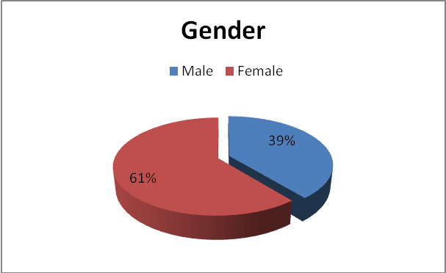

Figure 9
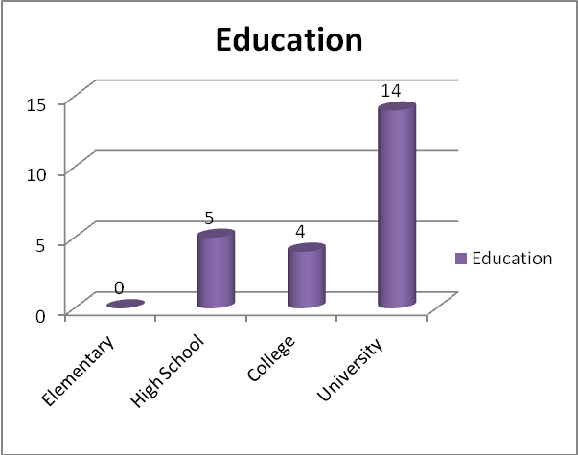
Figure 10
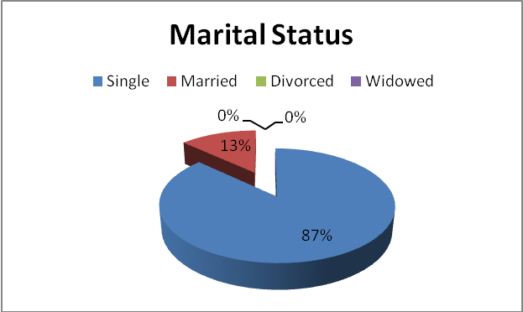

Figure 11
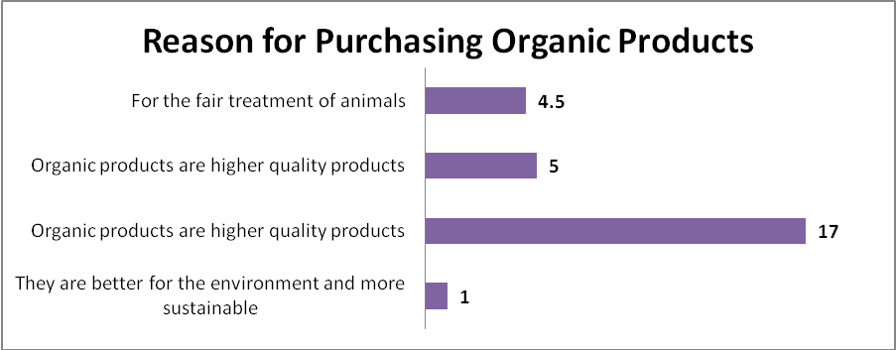

Figure 12
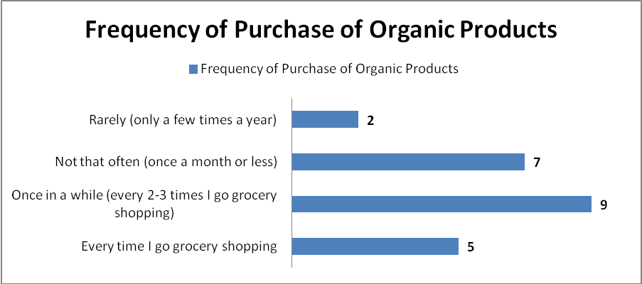

Figure 13
